

Diagnostic Solutions

Wireless Card for VCM /164-R9570
User Guide

R1.1

Copyright © 2007 Teradyne Diagnostic Solutions. All rights reserved.

Reproduction, transfer, distribution or storage as part or all of the contents in this document in any form without the prior written permission of Teradyne Diagnostic Solutions is prohibited.

Teradyne Diagnostic Solutions reserves the right to make changes and improvements to any of the products described in this document without prior notice.

Under no circumstances shall Teradyne Diagnostic Solutions be responsible for any loss of data or income or any special, incidental, consequential or indirect damages howsoever caused.

The contents of this document are provided “as is”. Except as required by applicable law, no warranties of any kind, either express or implied, including, but not limited to, the implied warranties of merchantability and fitness for a particular purpose, are made in relation to the accuracy, reliability or contents of this document.

Teradyne Diagnostic Solutions reserves the right to revise this document or withdraw it at any time without prior notice.

Contents

Introduction 3
Intended Use of Equipment 3
Features 3
System Requirements 3
Product Safety Notices 4
How to Identify Safety Notices 4
IMPORTANT SAFETY NOTICES 4
Installation 6
Installing the Wireless Card into the VCM 6
Configuration 6
Setting up a Wireless VCM for use with IDS 6
Installing the software 7
Connecting the VCM for configuration 7
Running the Wireless Configuration Wizard 7
Using the Wireless Card Manager 10
Manufacturer Contact Information 11
Technical Specifications 12

Introduction

Intended Use of Equipment

The Teradyne Wireless card is intended for use in vehicle diagnostic equipment within a vehicle assembly, test, service, or repair environment.

The Teradyne Wireless card, when installed within vehicle diagnostic equipment, provides the capability for wireless communication between the diagnostic equipment and host systems.

The performance of your wireless card can be affected by the location of your access point, building infrastructure, distance from access point, location of card in the vehicle, neighboring wireless networks, cordless phones, microwave ovens, and other wireless electronics in the vicinity.

Features

- Wireless connectivity between IDS and VCM.
- Reduced cables
- 12 Month Warranty

System Requirements

- The product has been verified using the Ford list of approved IDS laptop devices and Operating systems. The performance of this wireless card with any other device or Operating system is not guaranteed.
- This wireless card must be used in conjunction with IDS release R52 or higher.
- PC must have a wireless network adapter installed (802.11b or g).
Product Safety Notices

How to Identify Safety Notices
There are five types of safety information. These are examples:
CAUTION - This indicates the presence of a hazard that can cause damage to , a vehicle or other equipment connected to, or that might corrupt software if the hazard is not avoided.
WARNING - This indicates the presence of a hazard that can cause personal injury if the hazard is not avoided.
SPECIFIC HAZARD - Indicates the presence of a specific hazard, such as static sensitive components, electric shock risk or hot surface.
DO - Indicates a safety-critical activity that must be carried out.
DO NOT - Indicates a safety-critical activity or action that must not be carried out under any circumstances.

IMPORTANT SAFETY NOTICES

All users of this product must read and understand all safety notices.
This product has been designed, manufactured and tested to meet the requirements of international standards. However, as with any apparatus, care must be taken in its installation and use.
This document provides important safety related information relating to the Teradyne Wireless Card product.
You should read and understand this safety information before installing, and using the equipment
ALWAYS observe the safety warnings and instructions in this document.

CAUTION - This wireless LAN Card must only be installed in approved equipment.
CAUTION – There are NO user serviceable parts contained within or associated with this wireless card. You must contact the manufacturer for all repairs.
CAUTION – Using this card in a manner not specified by the manufacturer may impair the protection provided by this equipment.

WARNING – To reduce the risk of fire, do not operate this card within equipment near open containers of flammable liquid (such as gasoline). Do not allow the product to operate below or within 400mm (18 inches) of garage floor level.
WARNING – Do not use on wet surfaces or expose to rain.
WARNING – Changes or modifications to this product not expressly approved by Teradyne may void authority to operate equipment where the card has been installed.
WARNING – This wireless product must be operated at least 20cm away from the body.
WARNING – Do not insert the Teradyne Wireless card into any device until instructed to do so by the Wireless Configuration Wizard. The Teradyne Wireless card is for use with the VCM only.
WARNING – When using the Teradyne Wireless card, a strong signal is required in order to avoid interruptions in diagnostic procedures such as Module Reprogramming. To verify the signal strength run the Wireless Card Manager (see p. 10).
WARNING – Do not insert or remove the Teradyne Wireless card while the device is powered.
DO NOT - Expose this card to spilled liquids.
DO NOT - Use the card outside the supplier specification supplied by Teradyne.
DO NOT - Immerse card in water.
DO - Use the card only as described in this manual.
DO - Use this card in accordance with the operating procedures. For further details on installing and operating this card or any details relating to using it, contact Teradyne.
SAVE THESE INSTRUCTIONS.

Installation

Installing the Wireless Card into the VCM

WARNING: DO NOT insert the Teradyne Wireless Card into any device until instructed to do so by the Wireless Configuration Wizard. The Teradyne Wireless card is only to be installed in a VCM. DO NOT insert the Teradyne Wireless Card into your PC.

- Remove the wireless card cover from the VCM by rotating the black tabs.
- Insert the card fully home into the connector.
- Replace the cover and secure with tabs.

Configuration

Setting up a Wireless VCM for use with IDS

These instructions should be followed to configure your VCM for wireless use with IDS software. If you are not comfortable performing the following procedure and would like help or if you run into any concerns during the process pleaser contact your local Teradyne hotline.

The following table defines common terms used throughout these instructions and the Wireless Configuration Wizard.

Acronym/Term | Description
IDS | Integrated Diagnostic Software
VCM | Vehicle Communication Module
Host Cable | Used to connect the VCM to a computer. Common part numbers are H406, H416 and H417.
Teradyne Wireless Card | A PCMCIA card which enables the VCM to be used wirelessly with IDS.

The Teradyne Wireless card is intended to allow your VCM to connect to your wireless network. When configured and inserted into your device, the Teradyne Wireless card replaces the need to use a Host Cable with your device, however, the Host Cable can still be used when desired. If your wireless network settings change, these instructions can be used again to reconfigure your device to allow them to continue communicating wirelessly with IDS.

Installing the software

- Ensure that your PC has IDS Release 52 or newer installed.
- Install the Teradyne Wireless Card software by inserting the included media into the DVD/CD-ROM drive.
  - After a few moments, the setup application should appear on your computer screen.
  - If the Set up does not auto-run, click on the Start button and choose Run, enter D:\setup.exe for the Teradyne Wireless Card media (if “D” is the letter of the DVD/CDROM drive).
- Follow the on-screen instructions to install.

Connecting the VCM for configuration

To configure the VCM to use the Teradyne Wireless card, the device must be connected to a computer with both IDS and the Teradyne Wireless Card software installed. This connection must be made each time a device needs to be configured. The VCM must be configured with information about your wireless network in order to use the Teradyne Wireless Card. The Wireless Configuration Wizard setup software accompanying the Teradyne Wireless Card will attempt to configure the VCM automatically with this information.

NOTE: There may be some instances when the Wireless Configuration Wizard cannot determine the correct network settings. In this case, the information must be entered manually. Any questions regarding your particular network settings should be directed to your network administrator.

NOTE: Once a VCM is configured, the Host Cable is no longer required as long as the Teradyne Wireless card is inserted in the device and the network information does not change. The Host Cable can still be used as desired.

NOTE: Do not insert the Teradyne Wireless card until instructed by the Wireless Configuration Wizard

Running the Wireless Configuration Wizard

NOTE: A wired connection using a Host Cable to the VCM and the PC is required when running the Wireless Configuration Wizard.

- After installing the “Teradyne Wireless Card “software, run the “Wireless Configuration Wizard” from the Windows® Start > Programs > Teradyne Diagnostic Solutions> Teradyne Wireless Card menu.

- The Wizard’s first screen, shown here, requires that you select which of two possible methods the PC will use to connect wirelessly to the VCM. If your PC is already configured to access the Internet through a wireless connection, you will most likely accept the default selection; “Using a Wireless Access Point”. This will allow you to maintain your connection to the internet while you connect wirelessly to the VCM. This method does require that the VCM and the PC remain within the signal range of your wireless network, because everything gets routed through the wireless access point.
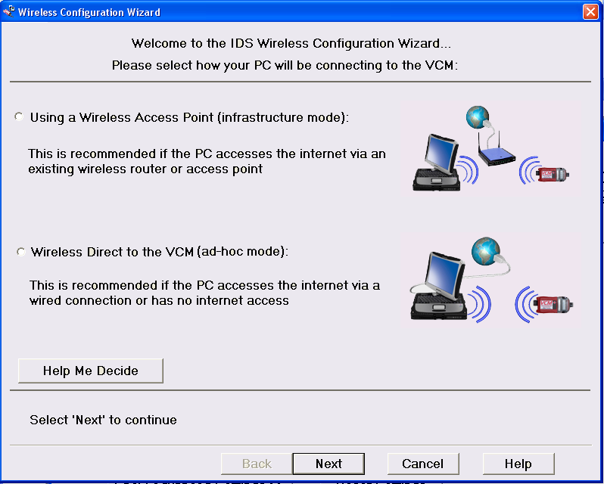
If, however, you want to maintain your ability to communicate beyond the signal range of your wireless network, or if there is no existing wireless access point installed, then you would select the second option; “Wireless Direct to the VCM”. This will establish a wireless connection between the VCM and the PC which can be maintained as long as they remain within a reasonable proximity of each other.

NOTE: You may find that even though your PC can connect to the wireless access point, the Wireless Card may or may not be able to, depending on its orientation within the vehicle. If this is the case, you may need to re-configure the VCM with the second option; “Wireless Direct to the VCM”. This would, of course, interrupt your wireless connection to the Internet.

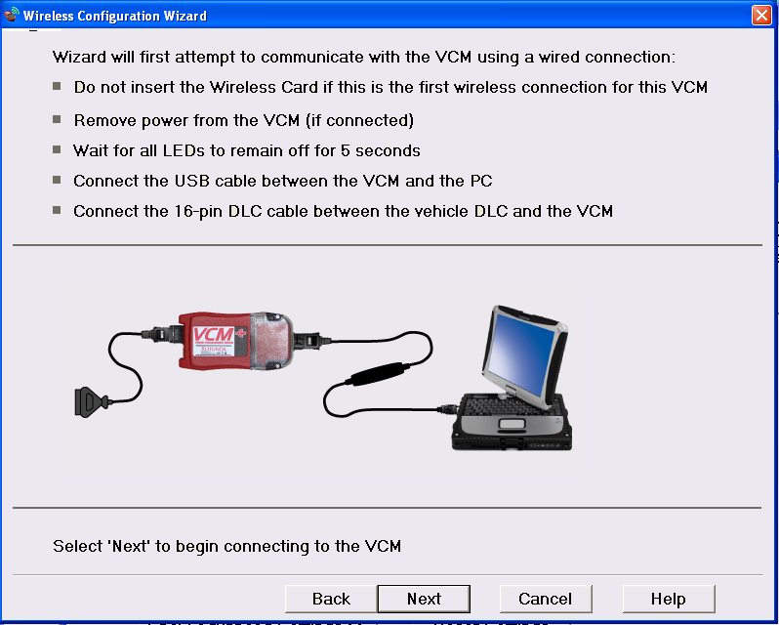
- Pressing the “Next” button takes you to this screen which prompts you to connect the VCM to the PC using the appropriate Host Cable and then power up the device. NOTE: If the VCM has never been configured previously, make sure a card has not been installed in the PCMCIA slot. Give the VCM a few moments to initialize as the PC needs to configure the wired connection.

Pressing “Next” will result in the Wizard connecting to the VCM to determine if it requires a software update. If prompted, allow the Wizard to update the software on the VCM. You may also be prompted to install the Teradyne Wireless Card into the VCM if it is not detected.

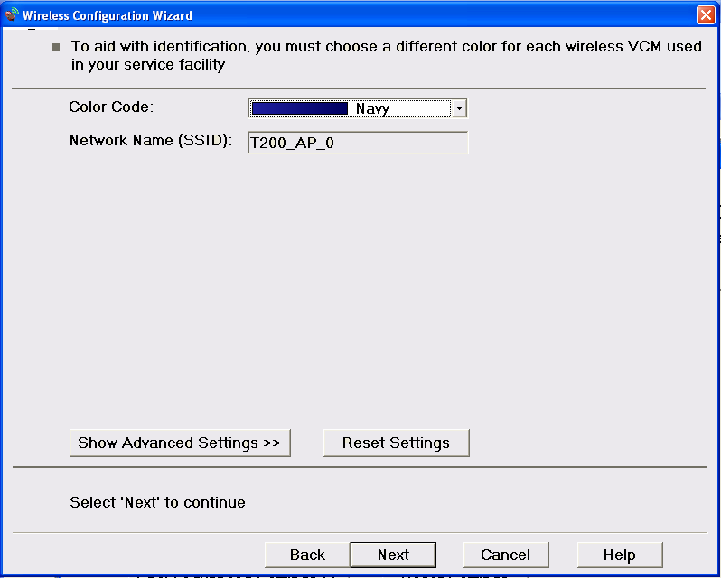
- The screen that appears after successfully communicating over the wired connection allows you to assign a color code to the device. Every VCM should be given a unique color and then be labeled with the selected color as this is how you would identify it if more than one were communicating on the same network.

If you selected to connect “Wireless Direct to the VCM”, the network name will be the same as the selected color code. Your network administrator can use “Show Advanced Settings” if security settings are required for this ad-hoc network configuration.

If you selected to “Use a Wireless Access Point” to connect, you may get prompted for a security key to gain access to the network. Contact your local network administrator if you are not familiar with these security settings.

- After pressing “Next”, the wizard will store the network settings and then instruct you to unplug the power from the device. The Host Cable will also be removed at this time followed by reconnecting power to the VCM.

If you selected to connect “Wireless Direct to the VCM”, the Wizard will attempt to automatically connect to the specified network. If this can not be done automatically for any reason, you will be instructed to manually configure the PC’s wireless network to the name corresponding to the color code selected previously. To do this you will need to access the PC’s “Wireless Network Connection” dialog (or equivalent utility provided by the PC manufacturer). If you are currently connected to a wireless access point network, we recommend that you manually disconnect before connecting to the new network. This will avoid automatically reconnecting to the access point whenever the VCM loses power. If you want to automatically reconnect to the access point, however, just connect to the new network without first disconnecting.

- Pressing “Next” will now attempt to establish the wireless connection. The Wizard will first check if the PC is connected to network and then search for VCM. Wait for the Wizard to show green and click Finish. It can take up to a minute for the indicator(s) to turn from red to green and this will only happen if your wireless adapter on the PC is able to communicate with the VCM.

Using the Wireless Card Manager

Along with the Wireless Configuration Wizard, the Teradyne Wireless card comes with the Wireless Card Manager. This application can be used to monitor signal strength, select specific devices for use with IDS, as well as modify some device settings.
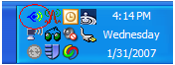
- Open the “Teradyne Wireless Card Manager” window by double clicking the icon in the system tray. If the icon is not present, the program can be started from the Windows® Start > Programs > Teradyne Diagnostic Solutions> Teradyne Wireless Card menu.

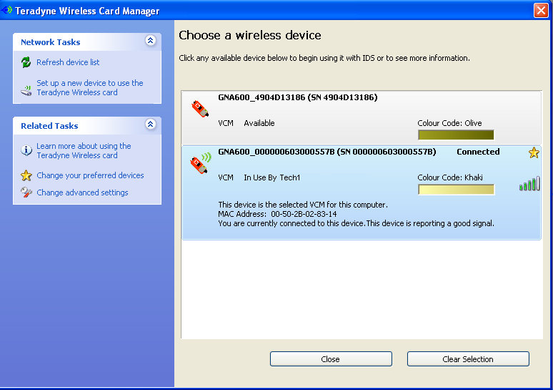
- The “Teradyne Wireless Card Manager” window will display all devices on the same network as your computer along with their wireless signal strength. The color code the VCM will be displayed in the list along with a serial number which will match the number imprinted on the back of the device.

- To select your VCM, highlight it on it in the list and click the “Select” button. After a few moments, your device should indicate “Connected” and have the star icon appear next to its information. Until a different VCM is selected, this star will indicate the default device for the PC and will automatically connect to it whenever it detects a signal.
Manufacturer Contact Information

Teradyne Diagnostic Solutions Limited
Orion Business Park
Bird Hall Lane
Stockport
Cheshire
SK3 0XG
United Kingdom

Phone: ++44 (0) 161 491 9191

Teradyne Diagnostic Solutions Incorporated
28970 Cabot Drive
Suite 100
Novi, MI 48377
United States

Phone: (877) 722 8336

www.teradyne-ds.com

Technical Specifications

Teradyne Wireless Card

Part Number 164-R9570

Operating Voltage 5 Volts DC +/- 5%

Maximum Current 500 mAmps

Physical

Physical dimensions Width = 54, Length = 111, Depth = 7 (mm, Approx)

Environmental Specification Temperature -20°C to 50°C
Humidity 0% to 90%

Wireless LAN (WLAN) environmental connections

WLAN Interface Conforms to IEEE 802.11b/g

WLAN Transfer Rate 802.11g: 6, 9, 12, 18, 24, 36, 48, 54Mbps with dynamic fallback.
802.11b: 1,2,5.5,11Mbps with dynamic fallback.

WLAN Frequency Band 2.4G~2.4735GHz (ISM Band)

Operational Channels Channel 1~11 (For all countries)

Security Modes WEP (Open/Shared with 64/128 bit)
WPA-PSK (TKIP/AES)
WPA2-PSK (AES)

Antenna Dual Ceramic Chip Antenna

LED Function Green LED (nearest center of card) – Flashes for scanning / associating, on when associated
Amber LED (nearest card edge) – Software configured, not currently used

Federal Communication Commission Interference Statement

This equipment has been tested and found to comply with the limits for a Class B digital device, pursuant to Part 15 of the FCC Rules. These limits are designed to provide reasonable protection against harmful interference in a residential installation. This equipment generates, uses, and can radiate radio frequency energy and, if not installed and used in accordance with the instructions, may cause harmful interference to radio communications. However, there is no guarantee that interference will not occur in a particular installation. If this equipment does cause harmful interference to radio or television reception, which can be determined by turning the equipment off and on, the user is encouraged to try to correct the interference by one of the following measures:

- Reorient or relocate the receiving antenna.
- Increase the separation between the equipment and receiver.
- Connect the equipment into an outlet on a circuit different from that to which the receiver is connected.
- Consult the dealer or an experienced radio/TV technician for help.

This device complies with Part 15 of the FCC Rules. Operation is subject to the following two conditions: (1) This device may not cause harmful interference, and (2) this device must accept any interference received, including interference that may cause undesired operation.

FCC Caution: Any changes or modifications not expressly approved by the party responsible for compliance could void the user's authority to operate this equipment.

IMPORTANT NOTE:
FCC Radiation Exposure Statement:
This equipment complies with FCC radiation exposure limits set forth for an uncontrolled environment. End users must follow the specific operating instructions for satisfying RF exposure compliance. To maintain compliance with FCC RF exposure compliance requirements, please follow operation instruction as documented in this manual.

This transmitter must not be co-located or operating in conjunction with any other antenna or transmitter.

SAR compliance has been established in typical laptop computer(s) with CardBus slot, and product could be used in typical laptop computer with CardBus slot. Other application like handheld PC or similar device has not been verified and may not compliance with related RF exposure rule and such use shall be prohibited.

The availability of some specific channels and/or operational frequency bands are country dependent and are firmware programmed at the factory to match the intended destination. The firmware setting is not accessible by the end user.

Industry Canada Statement
This device complies with RSS-210 of the Industry Canada Rules. Operation is subject to the following two conditions:
1) This device may not cause interference and
2) This device must accept any interference, including interference that may cause undesired operation of the device

This device has been designed to operate with an antenna having a maximum gain of 2 dBi.
Antenna having a higher gain are strictly prohibited per regulations of Industry Canada. The required antenna impedance is 50 ohms.

To reduce potential radio interference to other users, the antenna type and its gain should be so chosen that the EIRP is not more than required for successful communication.

IMPORTANT NOTE:

IC Radiation Exposure Statement:
This equipment complies with IC radiation exposure limits set forth for an uncontrolled environment. End users must follow the specific operating instructions for satisfying RF exposure compliance. To maintain compliance with IC RF exposure compliance requirements, please follow operating instructions as documented in this manual.
Warranty Information

Terms and Conditions

The wireless card comes with a 1 year limited warranty. Warranty starts on the date of shipment from the distributor.

Limited warranty only applies to the normal use of the wireless card.

The warranty does not cover any damage or defects arising from:
- Failure to use the wireless card in accordance with written instructions of Teradyne Diagnostic Solutions Ltd, or use with vehicles, motors or systems other than those for which it is designed. This wireless card has been designed to work specifically with the VCM.
Note that it is particularly important to follow all written instructions in any software used with the wireless card. Failure to follow these instructions can result in permanent damage to the wireless card or the device in which the card is installed. Such damage is not covered by this warranty.

- Neglect or misuse of the wireless card including any damage arising from accident, abuse, fire, theft or acts of nature.

- Any alteration, modification or maintenance of the wireless card by a party other than Teradyne Diagnostic Solutions Ltd or without prior written consent Teradyne Diagnostic Solutions Ltd.

Teradyne Diagnostic Solutions Ltd is not responsible for any resultant damage caused to 3rd party equipment.

Standard warranty process

During the warranty period you can request an advance replacement in the event of a hardware failure. In most regions you will receive a replacement unit within 1 to 2 days of logging a call with the Hotline. The replacement unit will not be your original wireless card and may be a refurbished unit. Replacement units carry the same warranty expiration date as the original card you purchased.

You are required to return the suspect faulty wireless card to Teradyne Diagnostic Solutions Ltd in the same packaging used to send you the replacement wireless card. You will be responsible to pay the shipment and any insurance cost to return your suspect faulty wireless card to Teradyne Diagnostic Solutions Ltd. If the card isn’t returned within 30 days you will be responsible to pay for the replacement card you received.

Teradyne Diagnostic Solutions Ltd reserves the right to replace any failed units with different product which will provide the same or greater functionality.

Customer Service Hotline

You may call the service Hotline listed below to resolve concerns and replace faulty Teradyne Diagnostic Solutions Ltd wireless card.

Before contacting a Hotline please ensure that first you:
- Follow the Troubleshooting guide on the website listed below.
- Record the serial number of your faulty unit

Call the Teradyne Diagnostic Solutions Ltd Hotline if you need assistance with:
- Wireless card operational failure or error codes
- Wireless card installation/setup software

Please do not call a Teradyne Diagnostic Solutions Ltd Hotline if you need assistance with:
- Vehicle or diagnostic software concerns (including vehicle DTC’s)
- For these please contact your OEMs Technical Information Support Center
- Your dealer network, including wireless access points and routers, PC and printer configurations
- For these please contact your local IT Administrator

Teradyne Customer Hotlines for hardware support:

Country | Telephone | Fax | Email
USA | 1-877-722-8336 | 1-248-994-3788 | idsnorthamerica@teradyne-ds.com
Canada | 1-877-722-8336 | 1-248-994-3788 | idsnorthamerica@teradyne-ds.com

To download the latest wireless card software updates and wireless card documentation please visit the
following website: http://service.teradyne-ds.com/

